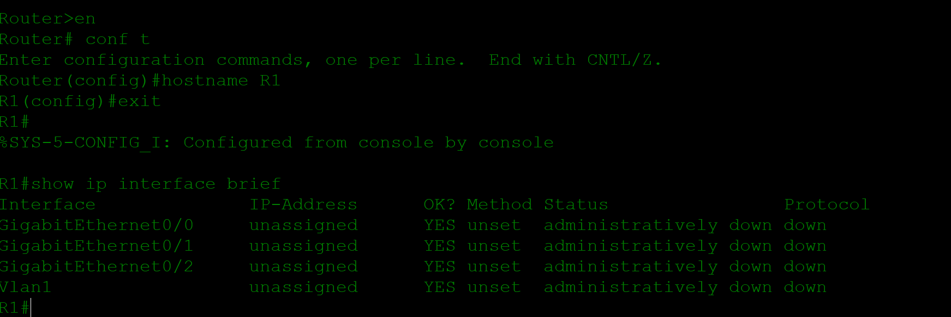

The diagram above is used a 'show' command to view a list of R1's interfaces, their IP addresses, status where show ip interface brief command does that.
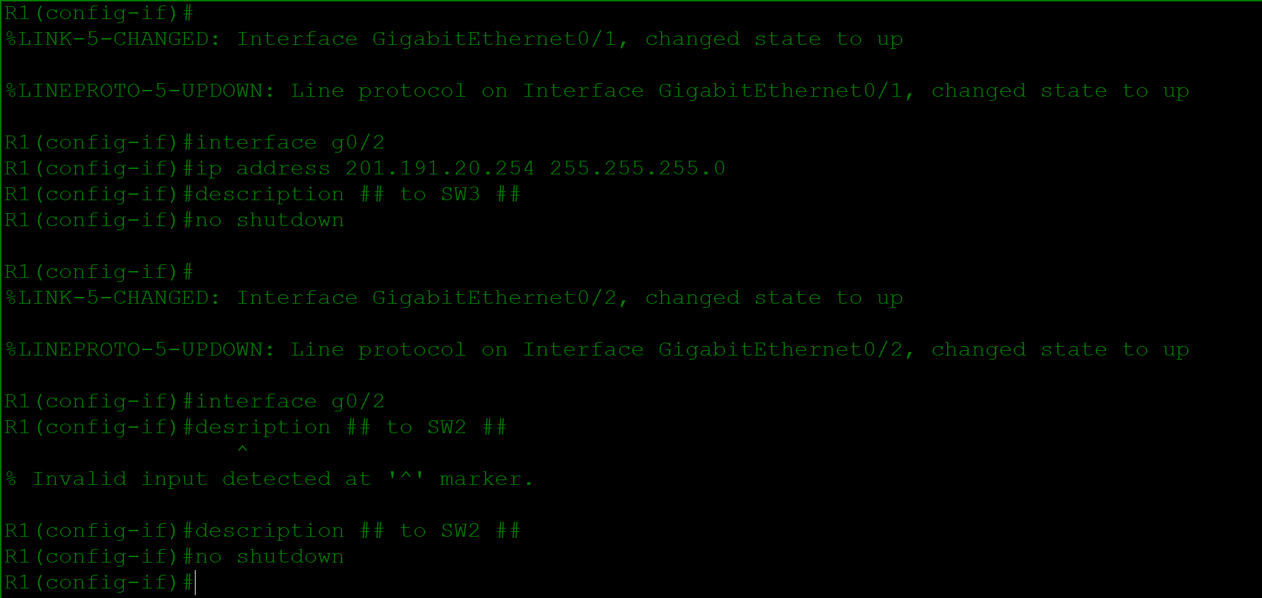

The screen shot above shows commands used to place the appropriate ip addresses and descriptions in packet tracer
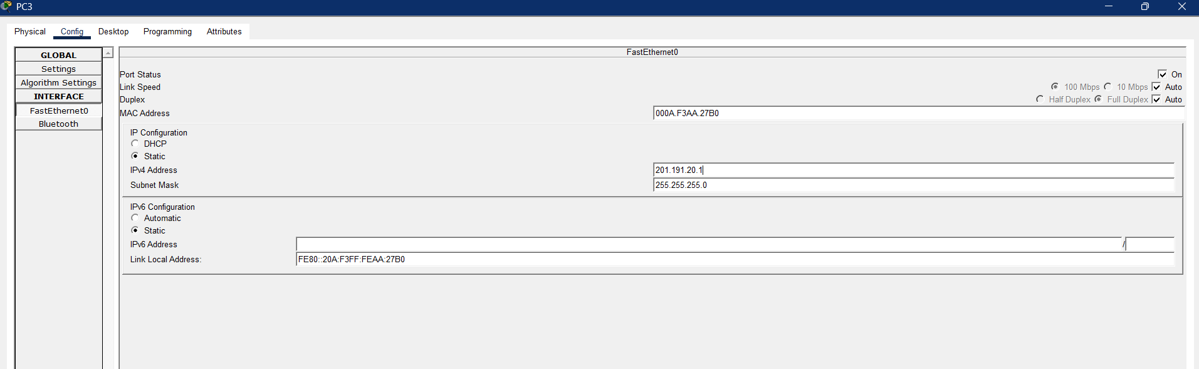
The diagram above shows setting the ip address of pcs

